PIZZA SALES SQL QUERIES

PROBLEM STATEMENT

**KPI's REQUIREMENT**

1. Total Revenue: The sum of the total price of all pizza orders.

2. Average Order Value: The average amount spent per order, calculated by dividing the total revenue by the total number of orders.

3. Total Pizzas Sold: The sum of the quantities of all pizzas sold.

4. Total Orders: The total number of orders placed.

5. Average Pizzas Per Order: The average number of pizzas sold per order, calculated by dividing the total number of pizzas sold by the total number of orders.

**CHARTS REQUIREMENT**

1.Daily Trend for Total Orders:

Bar chart that displays the daily trend of total orders over a specific time. This chart will help to identify any patterns or fluctuations in order volumes daily.

2.Monthly Trend for Total Orders:

Line chart that illustrates the hourly trend of total orders throughout the day. This chart will allow in identifying peak hours or periods of high order activity.

3.Percentage of Sales by Pizza Category:

Pie chart that shows the distribution of sales across different pizza categories. This chart will provide insights into the popularity of various pizza categories and their contribution to overall sales.

4.Percentage of Sales by Pizza Size:

Pie chart that represents the percentage of sales attributed to different pizza sizes. This chart will help to understand customer preferences for pizza sizes and their impact on sales.

5.Total Pizzas Sold by Pizza Category:

Funnel chart that presents the total number of pizzas sold for each pizza category. This chart will allow us to compare the sales performance of different pizza categories.

6. Top 5 Best Sellers by Revenue, Total Quantity and Total Orders

Bar chart highlighting the top 5 best-selling pizzas based on the Revenue, Total Quantity, Total Orders. This chart will help us identify the most popular pizza options.

7. Bottom 5 Best Sellers by Revenue, Total Quantity and Total Orders

Create a bar chart showcasing the bottom 5 worst-selling pizzas based on the Revenue, Total Quantity, Total Orders. This chart will enable us to identify underperforming or less popular pizza options.

SQL QUERIES AND RESULTS

1. Create database in sql and import table using Table Import Wizard.
2. View whole table to confirm complete upload



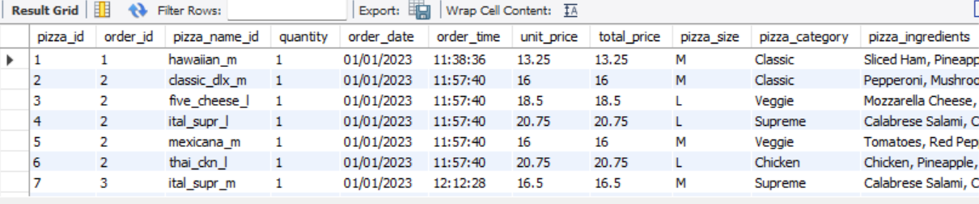

1. KPI Requirements
2. Total revenue:



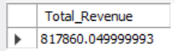

1. Average Order Value:



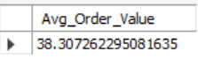

1. Total Pizza sold





1. Total Orders Placed



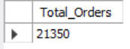

1. Average Pizza Per Order





CHART REQUIREMENTS

1. Total Sales and Percentage Sales per Pizza Category

1. Total Sales and Percentage Sales Per Pizza Size

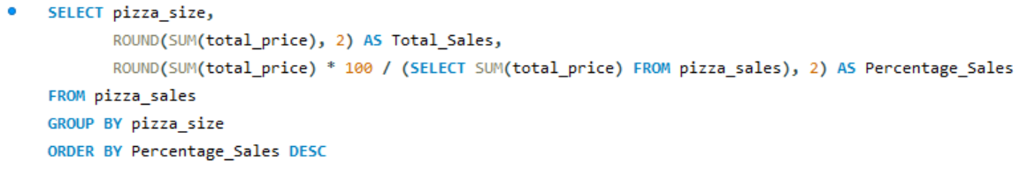

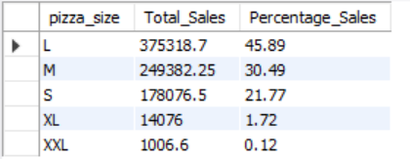

1. Top 5 Best Pizzas by Revenue

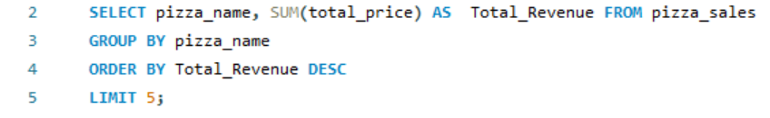

1. Bottom 5 Pizzas by Revenue

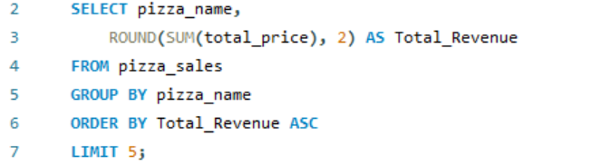

1. Top 5 Pizzas by Quantity

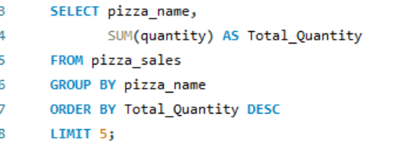

1. Bottom 5 Pizzas Per Quantity

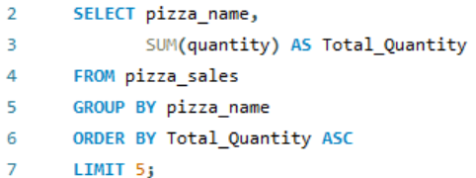

1. Top 5 Pizzas Per Order

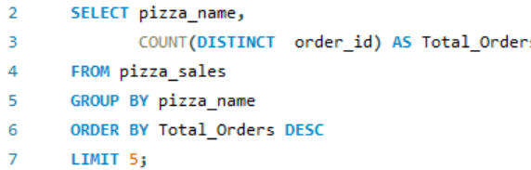

1. Bottom 5 pizzas Per Order

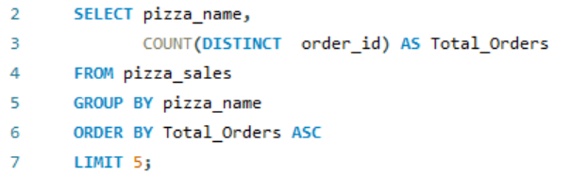

POWERBI

1. Data Cleaning

Replace Values: M, S, L, XLarge to Medium, Regular, Large and X-Large respectively

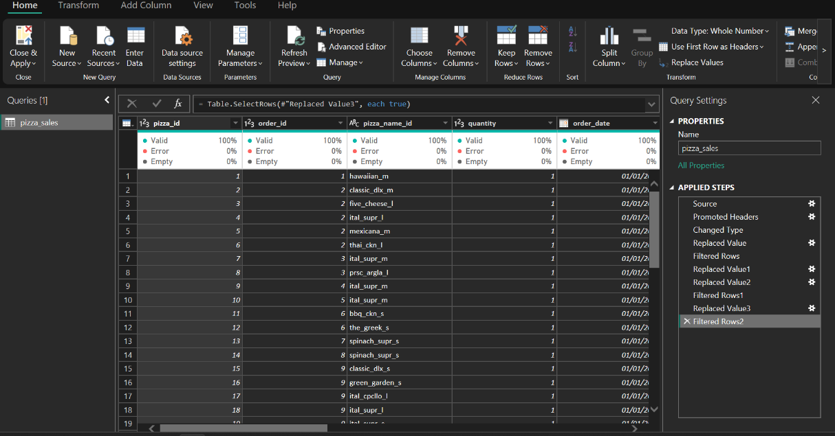

1. KPIs:

Create New Measures to calculate KPIs











Create CARD visual to display KPIs and compare values with SQL result

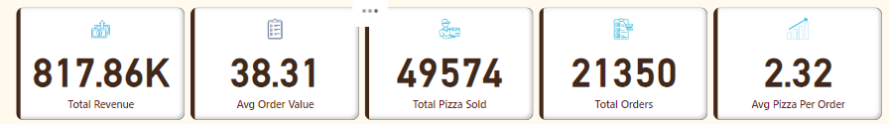

Create column for weekday using power query

* In Transform Data, highlight column for order_date, select Add column, go to date and click dropdown arrow then select Name of Day
* To get just the initials of the day name, I used dax function:



To be able to sort the bars according to days, create a new measure

-Transform data, click on Add column, then select conditional column and rename column as Day Number

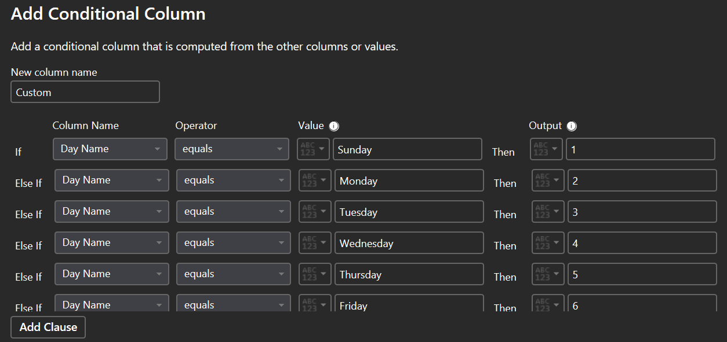 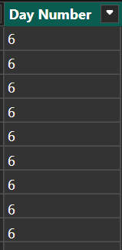

On the chart, select the column for order_day, go to columns and select the sort by column and click Day Number

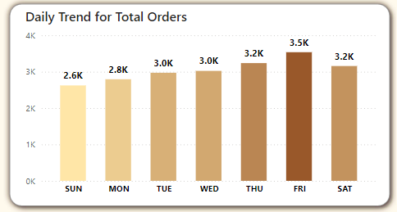

Do same thing for Month

In Transform Data, Select Order_Date -> Add Column -> Date -> Name of Month (**Month Name**)

Select Order_Date -> Add Column -> Date -> Month (**Month Number**)

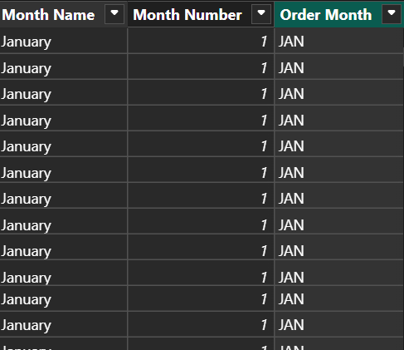

On the chart, select the column for order_month, go to columns and select the sort by column and click Month Number. Then on the chart, select three dots, go to sort axis and select order month and sort by ascending.

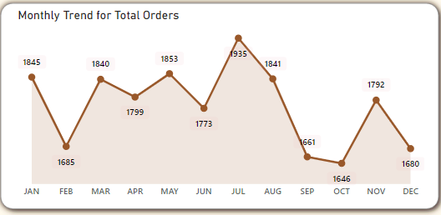

Percentage sales by Pizza Category: Donut chart plotting Pizza Category by Total Revenue.

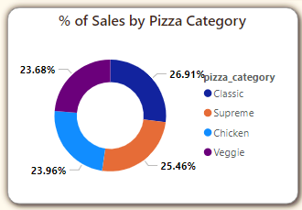

Percentage sales by Pizza Size: Donut chart plotting Pizza Size by Total Revenue.

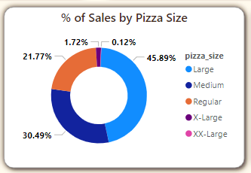

Total Pizzas sold by pizza category: Funnel chart plotting pizza category by total pizza sold.

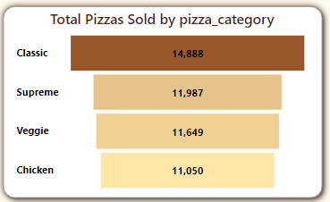

Insights and slicers

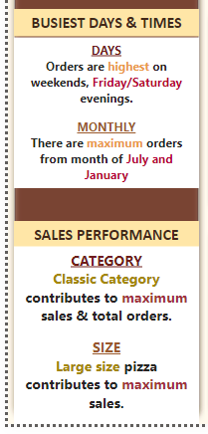

Dashboard 2

Top 5 and Bottom 5 pizzas by revenue: Bar chart plotting pizza name against total revenue. Then use filters to get top and bottom 5.

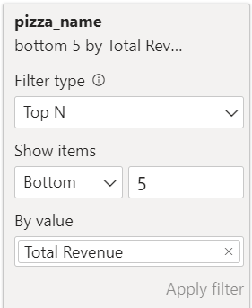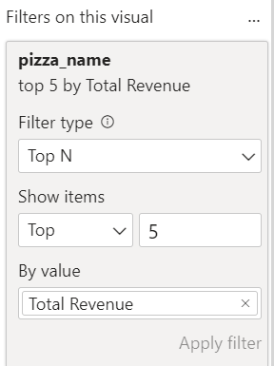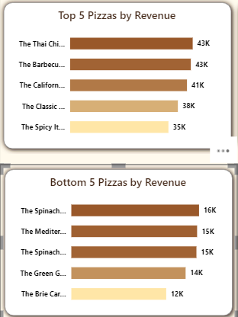

Top 5 and Bottom 5 pizzas by quantity: Bar chart plotting pizza name against total pizza sold. Then use filters to get top and bottom 5.

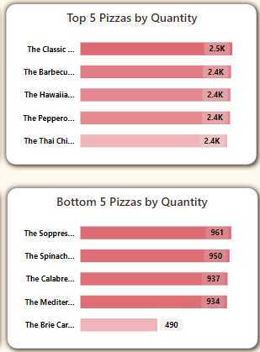

Top 5 and Bottom 5 pizzas by total orders: Bar chart plotting pizza name against total orders. Then use filters to get top and bottom 5.

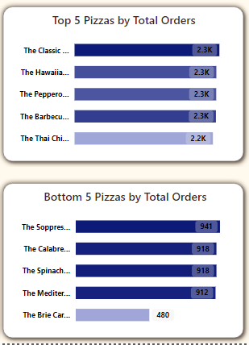

Best/Worst Seller Pizzas:

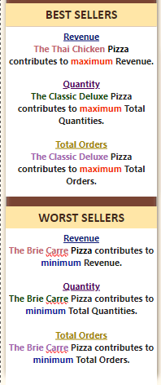

Home and Navigator Buttons

Insert > Buttons > Navigator > Page Navigator then Format > Visuals > Show

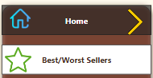

Home Page

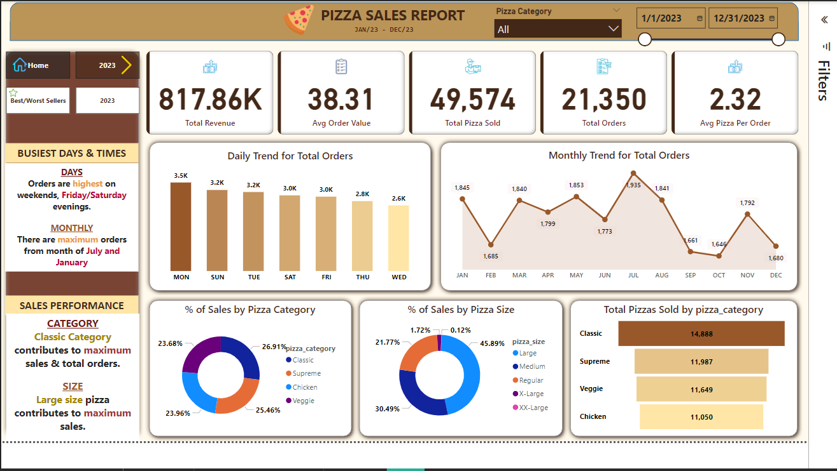

Best/Worst Seller Page

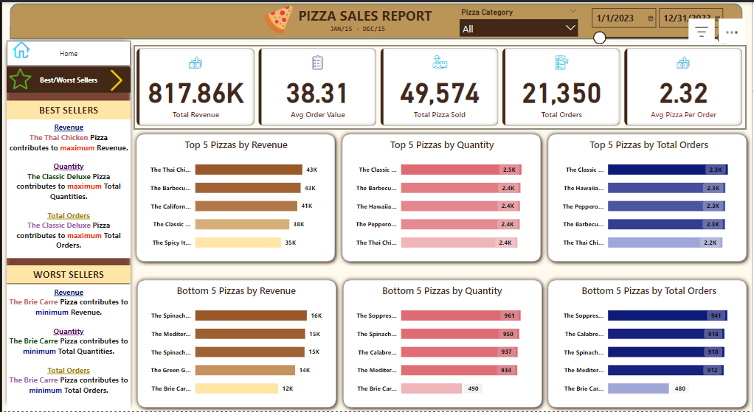

**INSIGHTS AND RECOMMENDATION**

**Insights:**

**1. Total Revenue & Order Insights:**

- Total Revenue: ₦817.86K for the period.

- Total Orders: 21,350 orders placed.

- Average Order Value: ₦38.31 per order.

- Average Pizzas per Order: 2.32 pizzas per order.

- Total Pizzas Sold: 49,574 pizzas.

**2. Top & Bottom Sellers (Best/Worst Sellers Page):**

- **Top 5 Pizzas by Revenue:**

- The Thai Chicken Pizza generated the highest revenue (₦43K), followed by Barbecue, California, and others.

**- Top 5 Pizzas by Quantity:**

- The Classic Deluxe Pizza sold the highest quantity (2.5K), followed closely by Barbecue, Hawaiian, and others.

**- Top 5 Pizzas by Orders:**

- Classic Deluxe was ordered the most, followed by Hawaiian and Pepperoni.

**- Bottom 5 Pizzas (Low Sellers):**

- The Brie Care Pizza has the lowest performance across revenue, quantity, and total orders, suggesting it is the least popular item.

**3. Daily & Monthly Sales Trends (2023 Page):**

**- Daily Trends:**

- Orders are highest on Mondays (3.5K) and decrease as the week progresses, with Wednesdays having the lowest orders (2.6K).

**- Monthly Trends:**

**-** Orders peak in July (1,935 orders) and August (1,841 orders). There is a sharp drop-off in orders from September to November.

**4. Sales by Pizza Category & Size:**

**- Pizza Category:**

- Classic Category leads with 26.91% of total sales, followed by Supreme, Veggie, and Chicken.

**- Pizza Size:**

- Large-sized pizzas contribute the most to sales (45.89%), followed by Medium and Regular sizes. XX-Large pizzas contribute the least (0.12%).

**5. Busy Days & Times:**

**- Busiest Days:** Fridays and Saturdays.

**- Busiest Months:** January and July have the highest number of orders.

**Recommendations**

**1. Promotion of Low-Selling Pizzas:**

**-** Consider running promotions, discounts, or combo offers for low-performing pizzas like the Brie Care Pizza to increase visibility and sales. Experiment with changes to the recipe or topping combinations to attract customers.

**2. Optimize for High-Demand Days:**

**-** With Mondays being the busiest day and orders declining towards midweek, consider offering mid-week specials to boost sales on Wednesdays and Thursdays. You could also increase staffing or resources for weekends, especially Friday and Saturday evenings when orders peak.

**3. Seasonal Promotions (Monthly Trends):**

- Since orders dip significantly from September to November, you could introduce seasonal promotions or marketing campaigns during these months (e.g., back-to-school deals, holiday specials) to maintain higher order levels.

**4. Capitalize on Large Pizzas:**

**-** Since Large-sized pizzas are the most popular, consider offering bundle deals on large pizzas or upselling customers from medium to large sizes for a small price increase.

**5. Refine Pizza Offerings by Category:**

- With Classic and Supreme pizzas leading the sales, focus on expanding variations of these popular categories. You can test new flavors within these categories while reviewing the Veggie and Chicken categories for potential new recipes or improved marketing.

**6. Revenue vs. Quantity Alignment:**

- There seems to be a good alignment between top-selling pizzas by revenue and quantity, suggesting a strong demand for certain products. You can use this data to ensure inventory and supply for these top sellers are optimized to avoid stockouts.